Name: Andiswa Asanda Mchunu
BrightLearn
Practical Exercise Google BigQuery.
Dataset: Retail Sales Dataset.

Question 1: WHERE clause.
filter all transactions that occurred in the year 2023.
SELECT *
FROM `sales-projects-494801.Sales.Retailsales`
WHERE EXTRACT(YEAR FROM Date) = 2023;
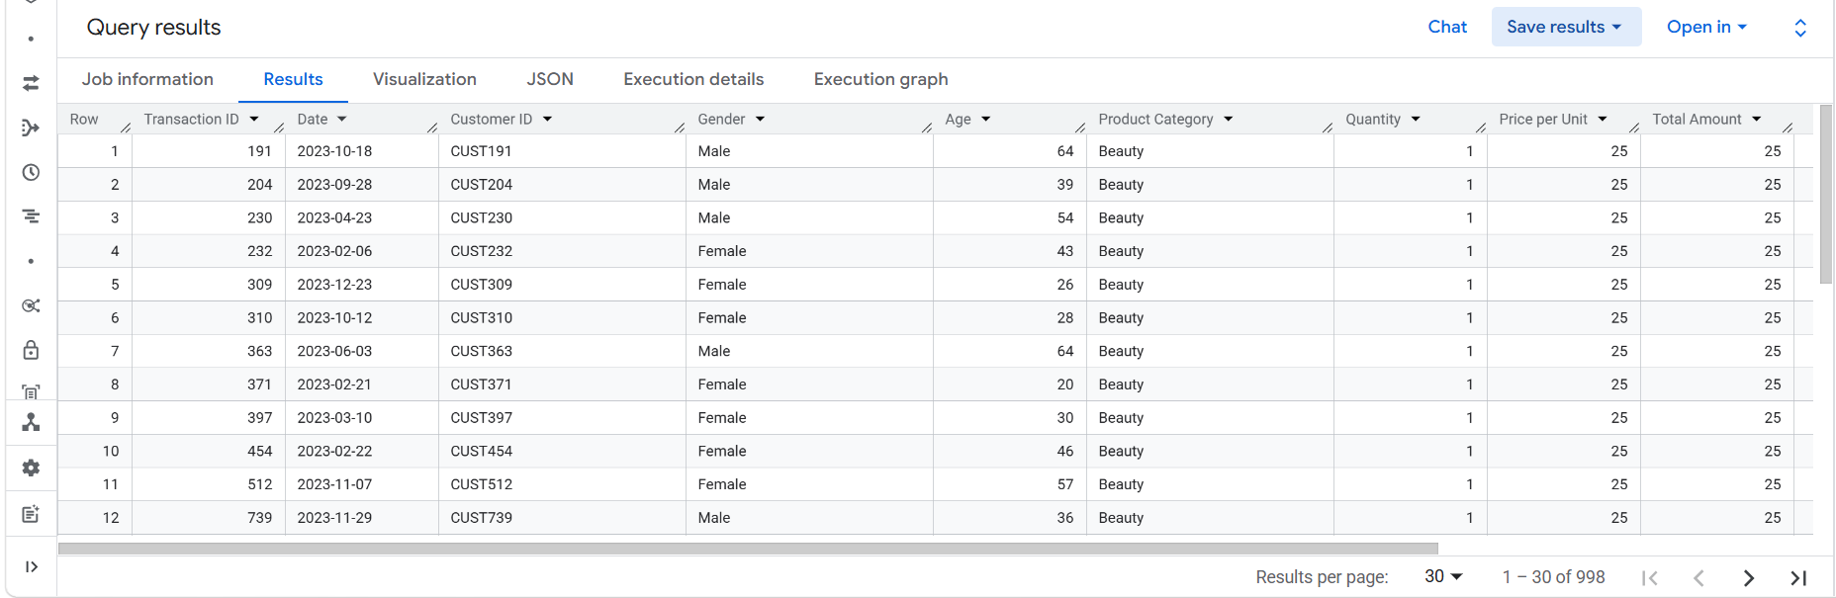

Question 2: Filtering + conditions
Display all transactions where the Total Amount is more than the average Total Amount of the entire dataset.

SELECT *
FROM `sales-projects-494801.Sales.Retailsales`
WHERE `Total Amount` > (SELECT AVG(`Total Amount`) FROM `sales-projects-494801.Sales.Retailsales`);
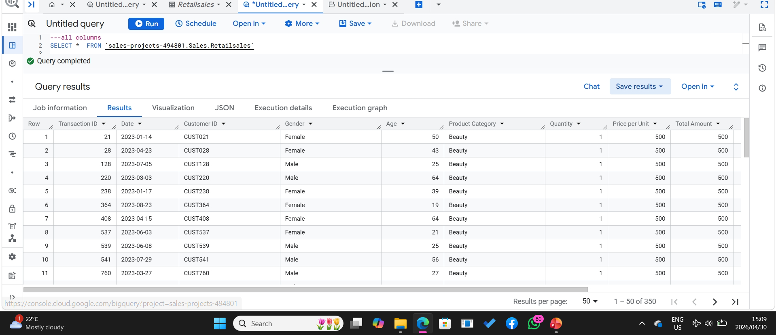

Question 3: Aggregate functions
Calculate the total revenue (sum of Total Amount).
Expected Output: Total_Revenue.

SELECT SUM(`Total Amount`) AS Total_Revenue
FROM `sales-projects-494801.Sales.Retailsales`
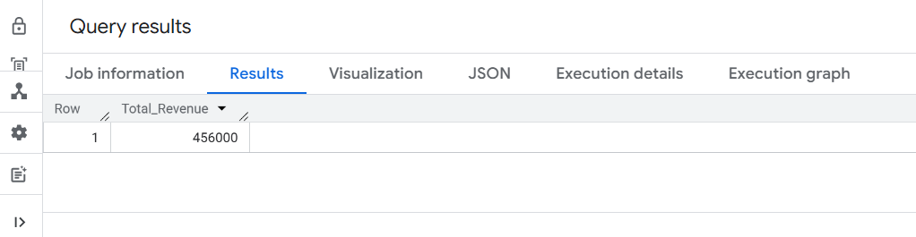

Question 4: DISTINCT
Display all distinct Product Categories in the dataset.
Expected Output: Product_Category

SELECT DISTINCT `Product Category`
FROM `sales-projects-494801.Sales.Retailsales` ;
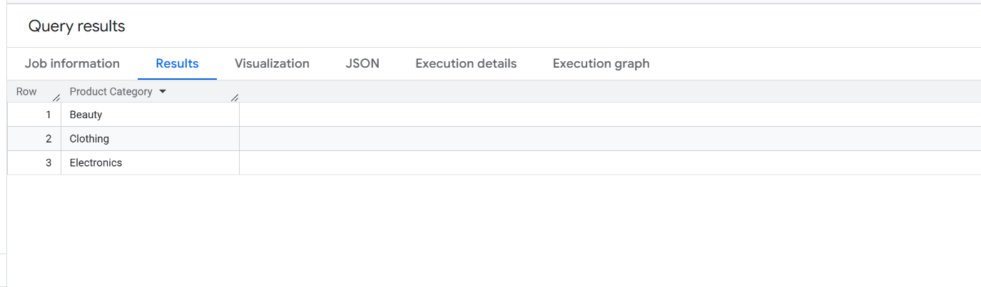
Question 5: GROUP BY
For each Product Category, calculate the total quantity sold.
Expected Output: Product_Category, Total_Quantity

SELECT `Product Category`,
SUM(Quantity) AS Total_Quantity
FROM `sales-projects-494801.Sales.Retailsales`
GROUP BY `Product Category`;

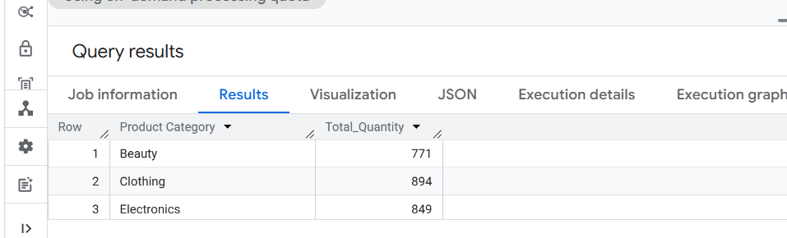

Question 6: CASE Statement
Create a column called Age_Group that classifies customers as 'Youth' (<30) 'Adult' (30–59) – 'Senior' (60+)
Expected Output: Customer_ID, Age, Age_Group
SELECT `Customer ID`,
Age,
CASE
WHEN Age < 30 THEN 'Youth'
WHEN Age BETWEEN 30 AND 59 THEN 'Adult'
WHEN AGE > 60 THEN 'Senior'
END AS Age_Group
FROM `sales-projects-494801.Sales.Retailsales`;

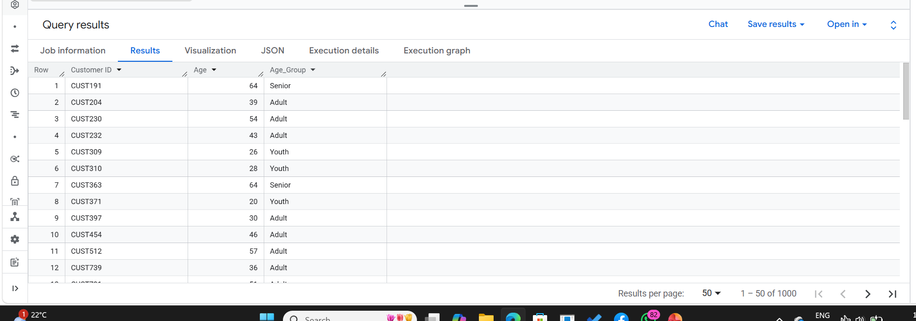

Question 7: Conditional Aggregation
For each Gender, count how many high-value transactions occurred (where Total Amount > 500).
Expected Output: Gender, High_Value_Transactions

SELECT Gender,
COUNT(CASE WHEN `Total Amount` > 500 THEN 1 END) AS High_Value_Transactions
FROM `sales-projects-494801.Sales.Retailsales`
GROUP BY Gender;
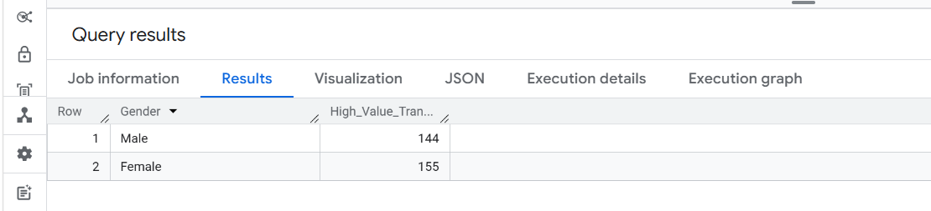

Question 8: HAVING Clause
For each Product Category, show only those categories where the total revenue exceeds 5,000.
Expected Output: Product_Category, Total_Revenue

SELECT `Product Category`,
SUM(`Total Amount`) AS Total_Revenue
FROM `sales-projects-494801.Sales.Retailsales`
GROUP BY `Product Category`
HAVING SUM(`Total Amount`) > 5000;

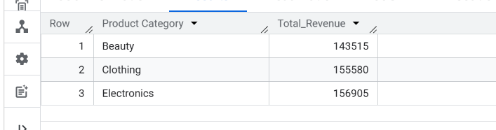

Question 9: Calculated Fields
Display a new column called Unit_Cost_Category that labels a transaction as:
'Cheap' if Price per Unit < 50
'Moderate' if Price per Unit between 50 and 200
'Expensive' if Price per Unit > 200
Expected Output: Transaction_ID, Price_per_Unit, Unit_Cost_Category

SELECT `Transaction ID` AS Transation_ID,
`Price per Unit` AS Price_per_Unit,
CASE
WHEN `Price per Unit` < 50 THEN 'Cheap'
WHEN `Price per Unit` BETWEEN 50 AND 200 THEN 'Moderate'
WHEN `Price per Unit` > 200 THEN 'Expensive'
ELSE 'Unknown'
END AS Unit_Cost_Category
FROM `sales-projects-494801.Sales.Retailsales`;

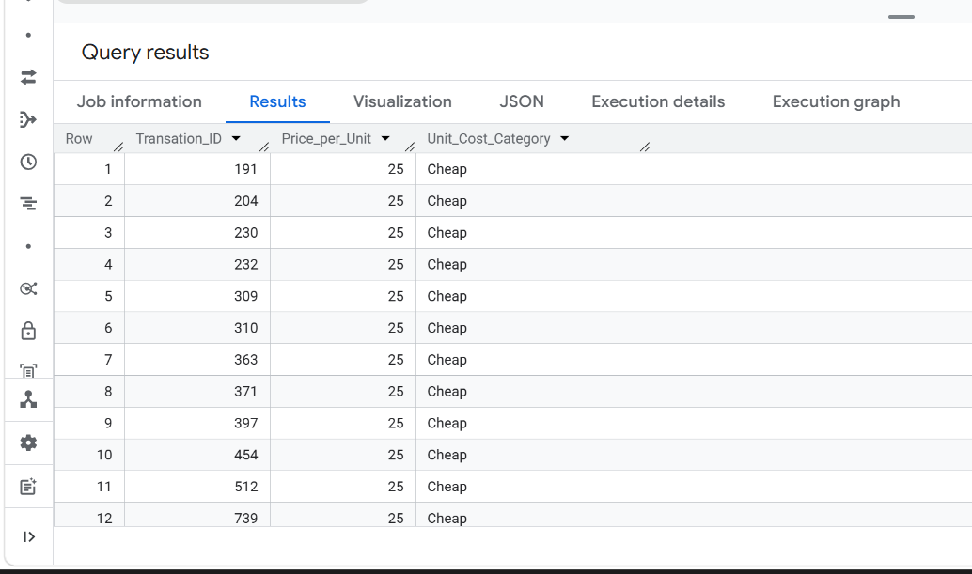

Question 10: Combining WHERE + CASE
Display all transactions from customers aged 40 or older and add a column Spending_Level showing:
High' if Total Amount > 1000
'Low' otherwise
Expected Output: Customer_ID, Age, Total_Amount, Spending_Level

SELECT `Customer ID`,
Age,
`Total Amount`,
CASE
WHEN `Total Amount` > 1000 THEN 'High'
ELSE 'Low'
END AS Spending_Level
FROM `sales-projects-494801.Sales.Retailsales`
WHERE Age >= 40;
